Problem Statement
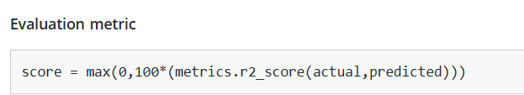
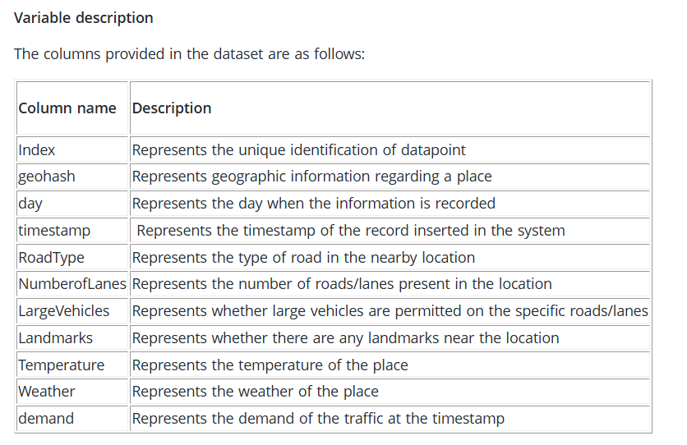
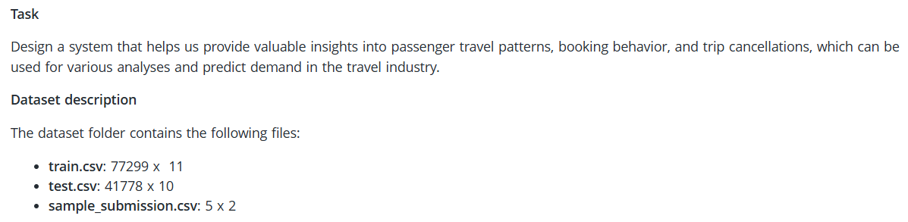
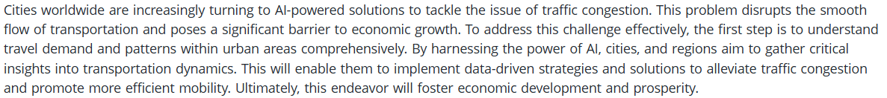
Traffic Demand Prediction

